Name: _____________________________________ Class: ____ Date: ___________________
Governments: China/Hong Kong/Taiwan
Purpose: To see the similarities and differences of Hong Kong, China and Taiwan’s government.
Research these countries and fill in the following information on the chart.
Country Flag | Form of Government | Current Leader | How are they chosen | How long are they in power | Different Political Parties
China
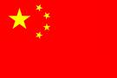
Hong Kong
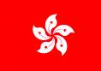
Taiwan
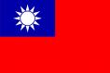
If you can’t find certain information put an N/A (Not available).
Taiwan:
http://tinyurl.com/2bslwk
China:
http://tinyurl.com/3aeane
Hong Kong:
http://tinyurl.com/29dvql
Or
http://www.gov.hk/en/about/govdirectory/govstructure.htm
http://www.gov.hk/en/about/govdirectory/govstructure.htm

http://www.gio.gov.tw/taiwan-website/5-gp/yearbook/04Government.pdf

http://english.gov.cn/2008-03/15/content_921051.htm

